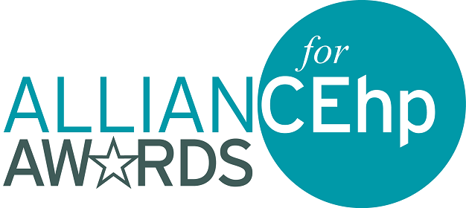

ABOUT THE 2027 APPLICATION PROCESS
For specific criteria for each award, including eligibility and evaluation information, as well as details regarding the content of your submission, visit the Alliance Awards webpage. Overall eligibility requirements include:
- The nominator must be an Alliance member, and at least one of the primary individuals involved in the planning, development, and implementation of a nominated activity/endeavor must be a member of the Alliance and listed as a nominee in the applicant information tasks.
- A nominated activity/endeavor must have been initiated within the specified time defined within the award eligibility information. This differs by award type.
- A nominated activity/endeavor may not be nominated for any other Alliance award in the same year nor have previously received any other Alliance annual award.
- Only one application per nominee (person or organization) may be submitted per award category. This includes individuals or organizations who participated as a collaborator on the activity, project, or initiative.
- Nominees (person or organization) may submit for no more than two award categories. This includes individuals or organizations who participated as a collaborator on the activity, project, or initiative.
- Nominees (person or organization) may not submit in an award category that they have won the previous year. This includes individuals and organizations who participated as a collaborator on the activity, project, or initiative.
- Commercial supporters may or may not be listed as nominees, depending on award eligibility information; please review specific award criteria for restrictions.
- The Awards Committee is made up of volunteers from across the member sections. To ensure the process of selecting winners is fair for all applicants, we do not allow employees/consultants of the organization submitting the nomination to review or score the award submission. This extends to educational partners and commercial supporters of the nominated activity/endeavor as well.

Tips:

- Tip 1: Read the award application instructions carefully … and follow them.
- Tip 2: Ensure your activity/project and your nominees meet all the requirements specific to the award for which you are applying.
- Tip 3: Be clear and concise in your descriptions (Graphics can be helpful).
- Tip 4: Provide enough information for the awards committee to review…but not too much information.
- Tip 5: Be specific about how and which National Learning Competencies were incorporated.
- Tip 6: Ensure you or your organization are not listed on more than the allotted number of submissions, which could result in disqualification.

